Office of Child and Youth Protection, Pastoral Center, (714) 282-3069

Parish safe environment safety training NEW curriculum, K-8
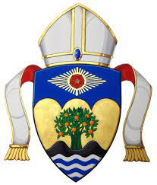
Loyola Press, Growing with God, Safe and Sacred

Order Form
Please submit order by Friday, June 30, 2023

Parish:
Address:
Name of person placing order and position:
Email:
Contact phone number:

Grade | #English Classes | #Cats | #Students | #Spanish Classes | #Cat | #Students
K
1
2
3
4
5
6
7
8
Total

Send your order to:
Anita Linton
Regional Sales Manager
Loyola Press
linton@loyolapress.com
(310) 367-1174

